first color palate

first choose the theme for hotel:

1) royal/luxury hotel - REJECTED - 2

2) Ancient Indian style hotel/traditional - FINE

3) Anime cafe? - REJECTED - 3

4) hotspring .... Japanese... - REJECTED – 1

palate for Ancient Indian style hotel:

current choices:

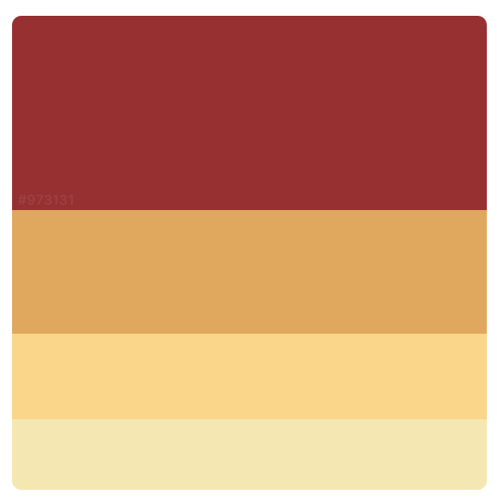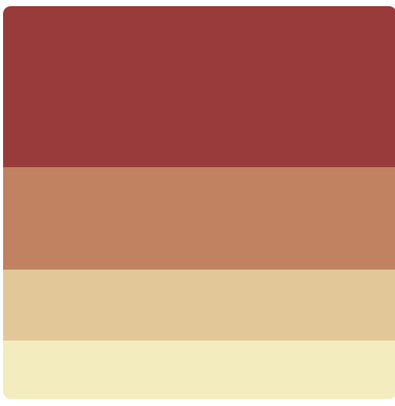

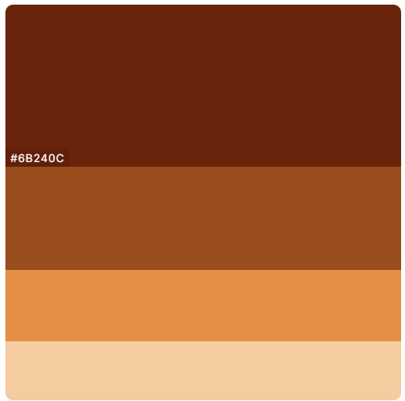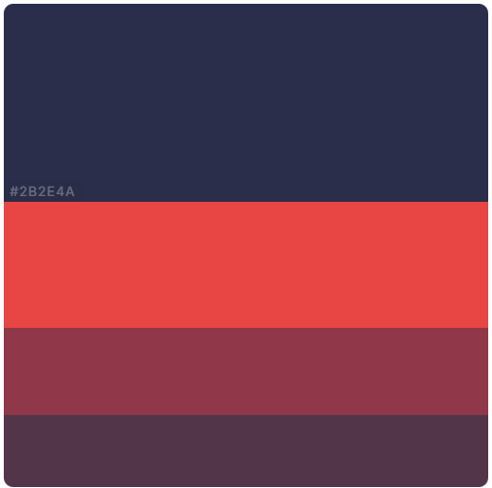

Try to create a layout and later try those palate and choose one.

First page:

About:

Should be traditional – serif family font

Must grab attention – use clashing plate

Content:

Hotel name

Hotel image (more towards this or abstract image

IDEAS:

Use gifs / animated sticker to give life to images

Current image for hotels:

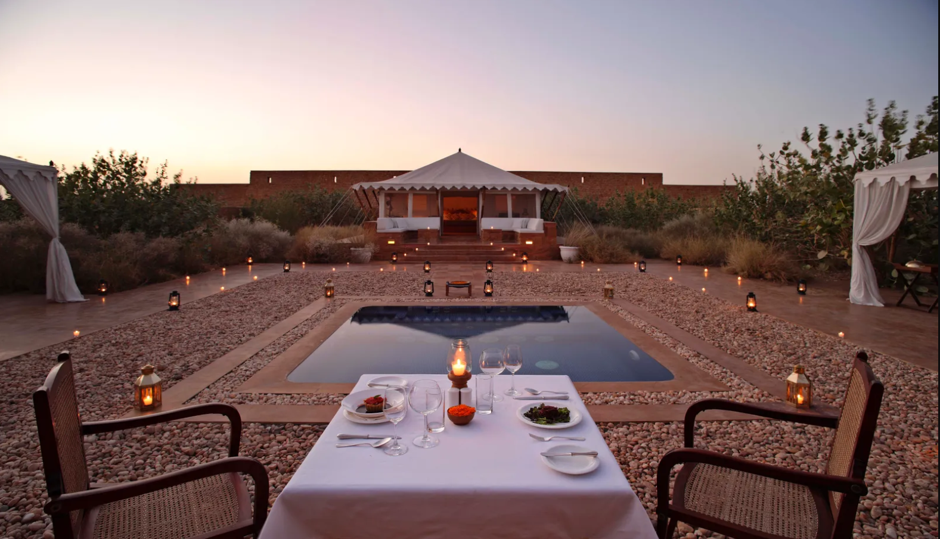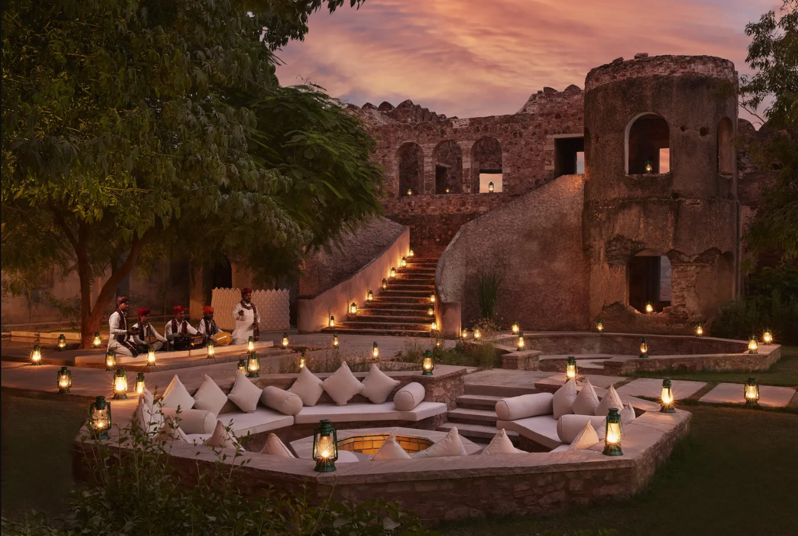

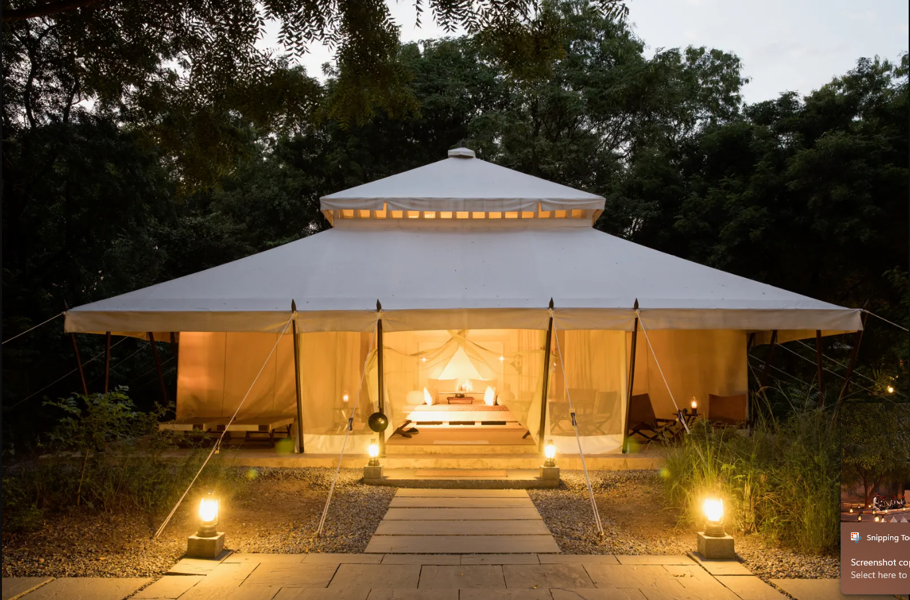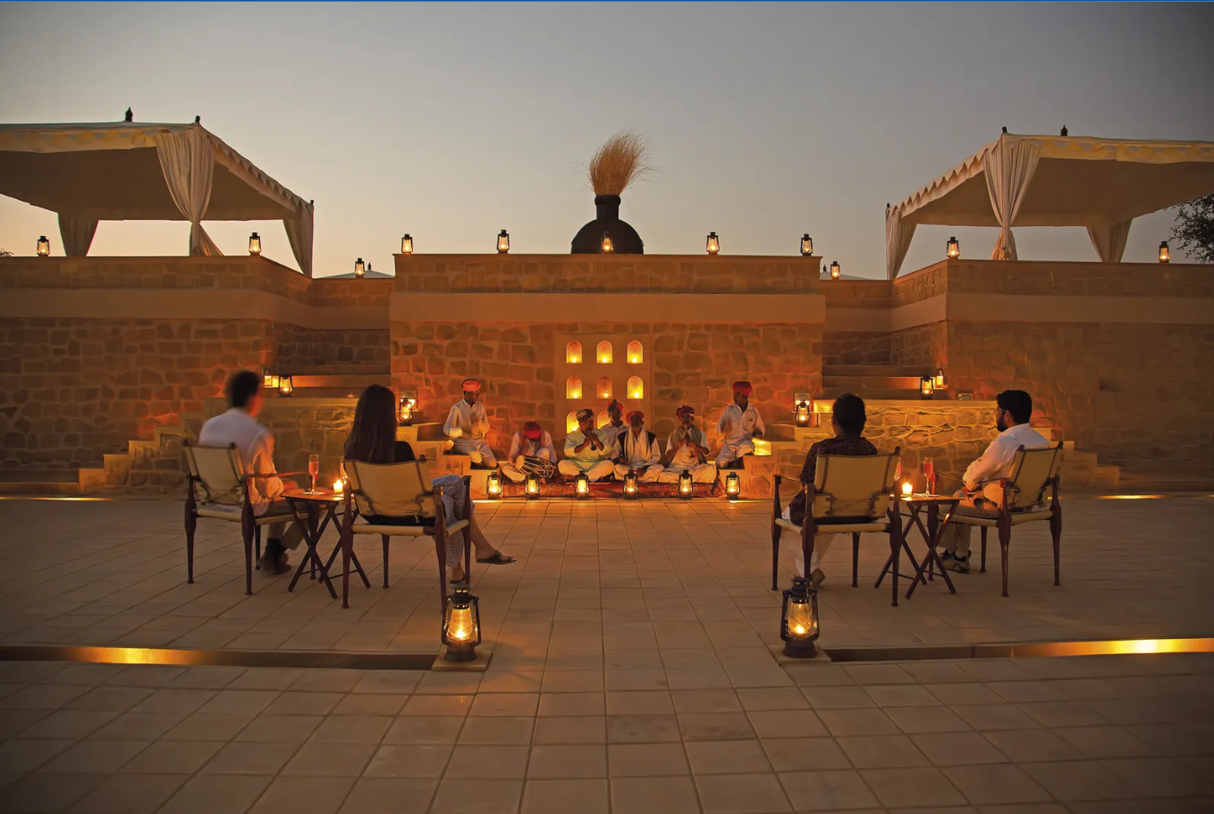

Image_names: tentDay, fort, tentNight, fortSong

First page: tentDay

Right side: image(tentDay)

Hotel name – serif

Hotel name in center (two colours with one color on overlapping with image and rest other color (black and white))

Left side: image or (background color from palate with some pattern on it)

If iamge – needs to imply something… and must be contrasting

Drafts:  
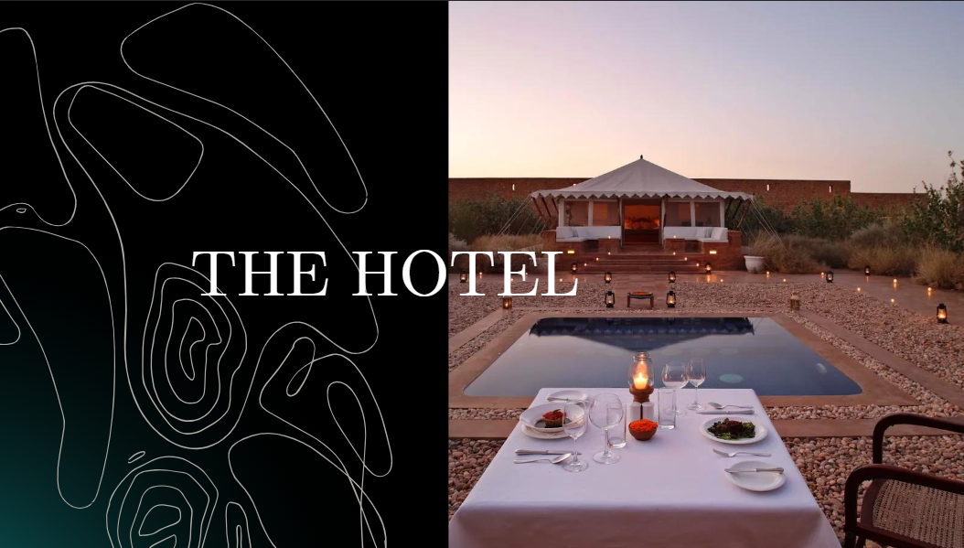

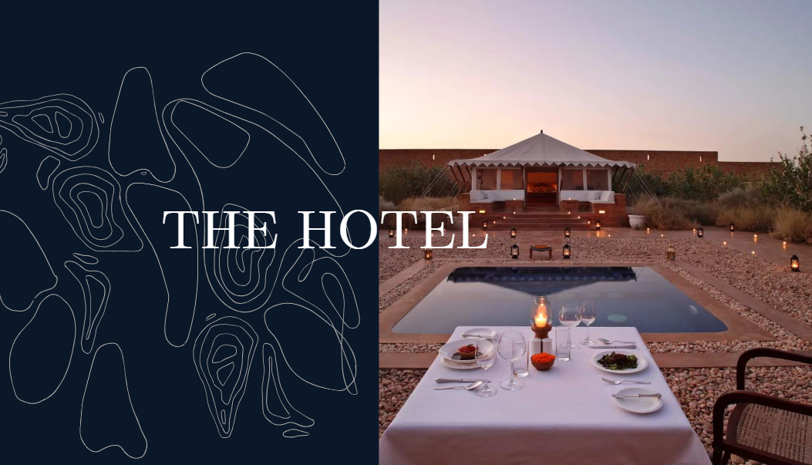

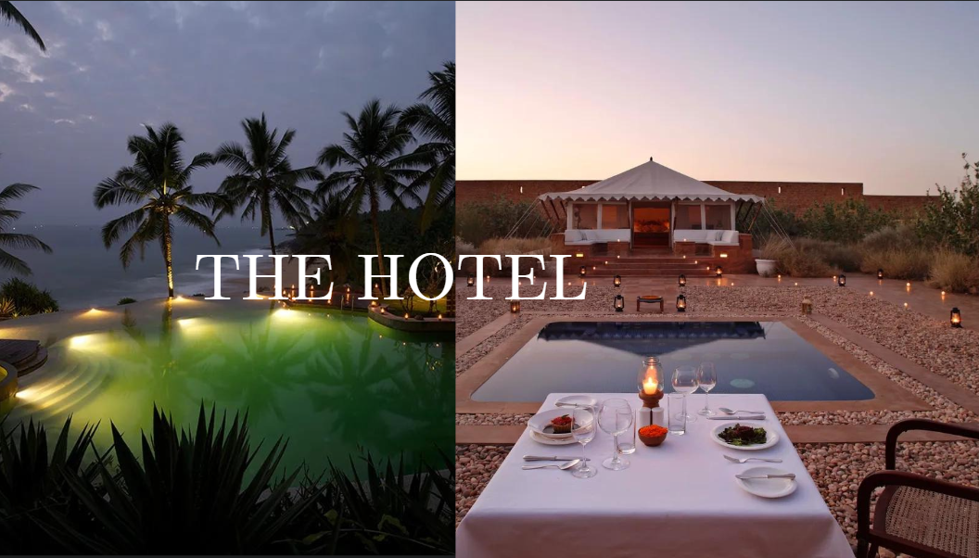

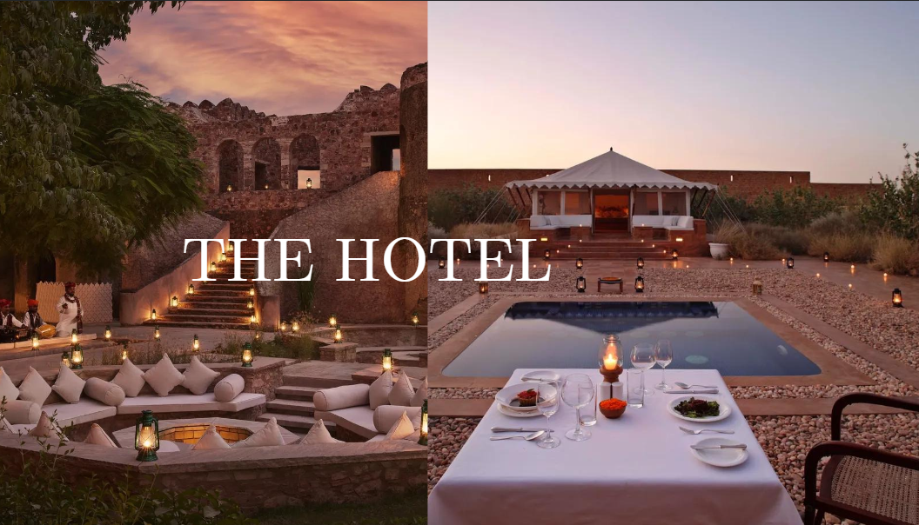

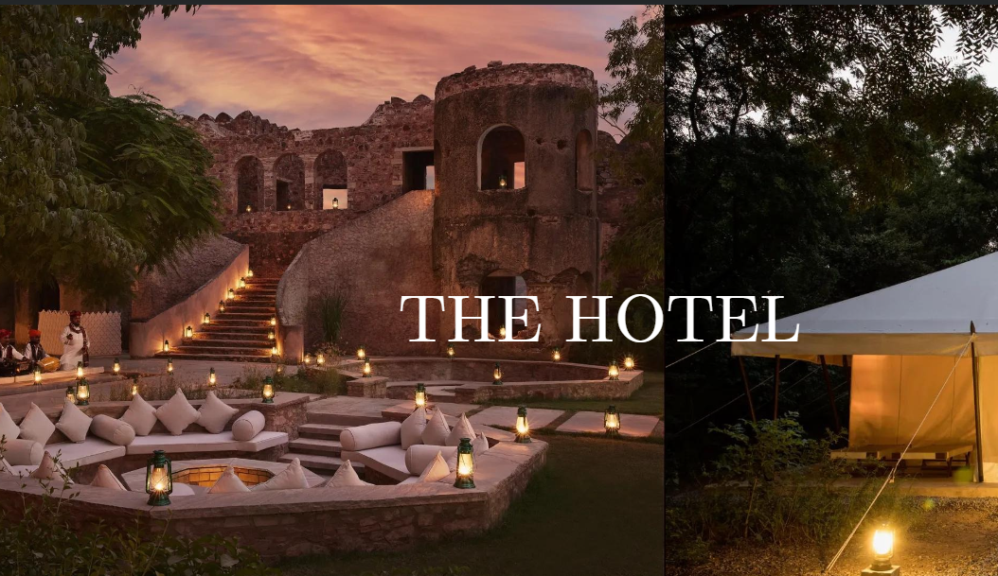

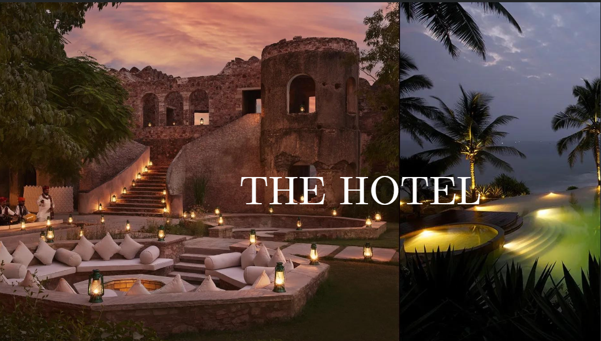

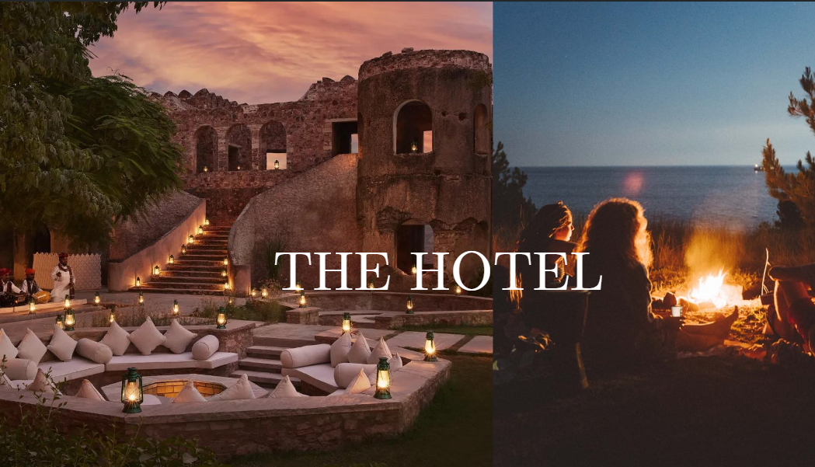

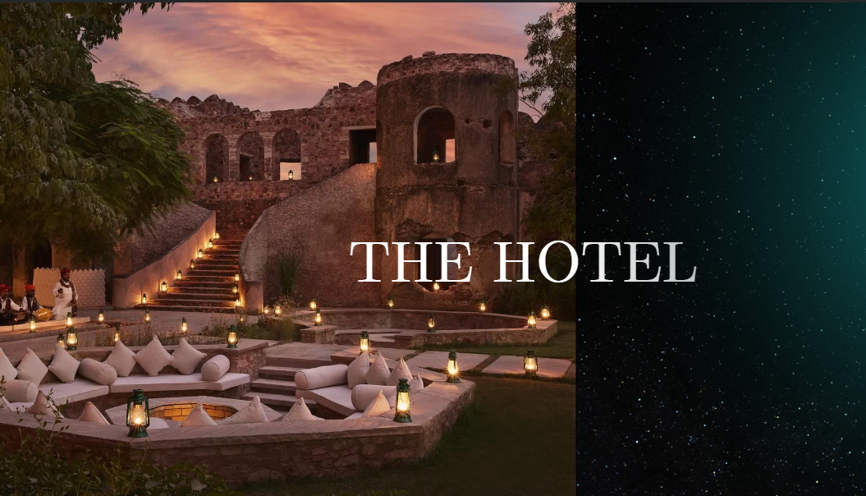

The final select:

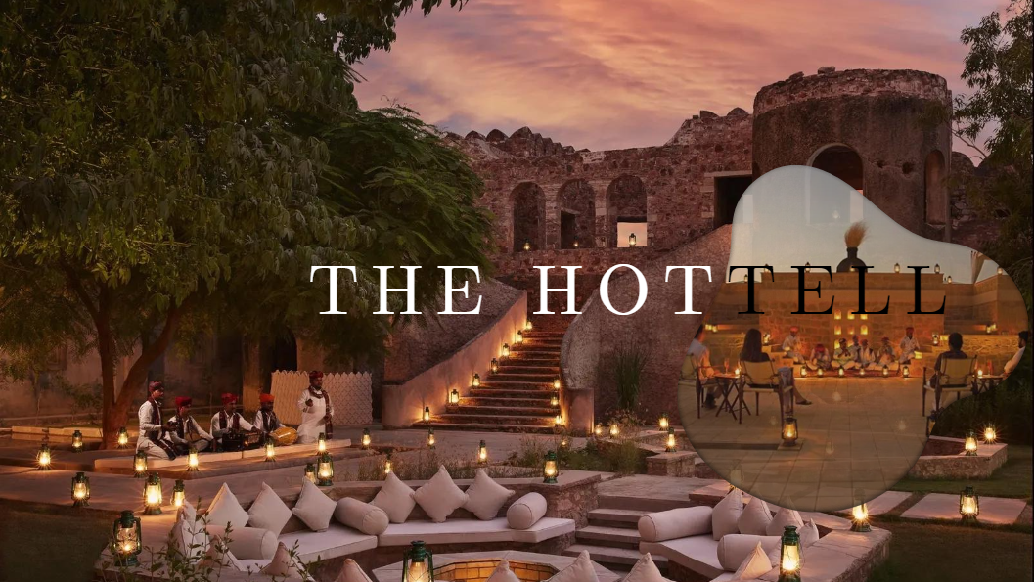

Final outcome: unsatisfied ☹ but fuck it. Moving on to next page.

Fuck it Here is the final output of all:

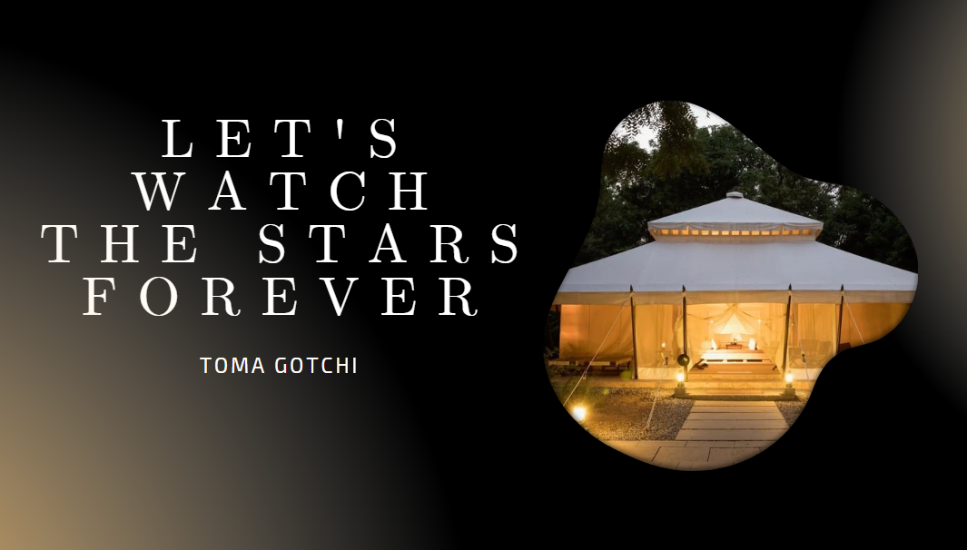

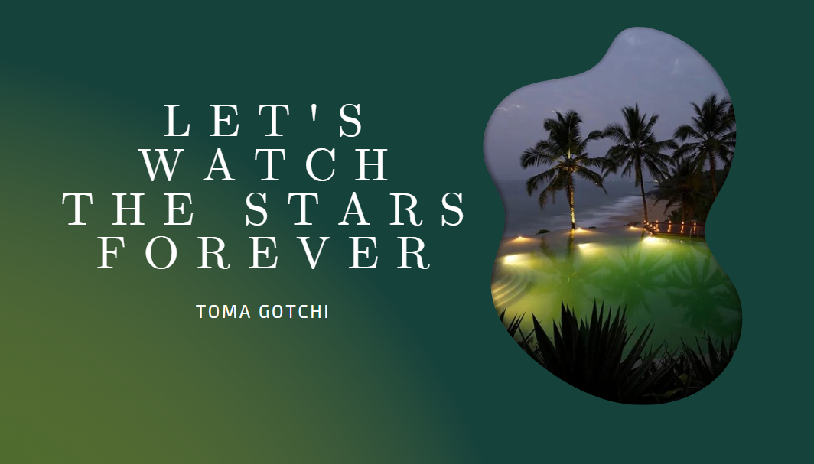

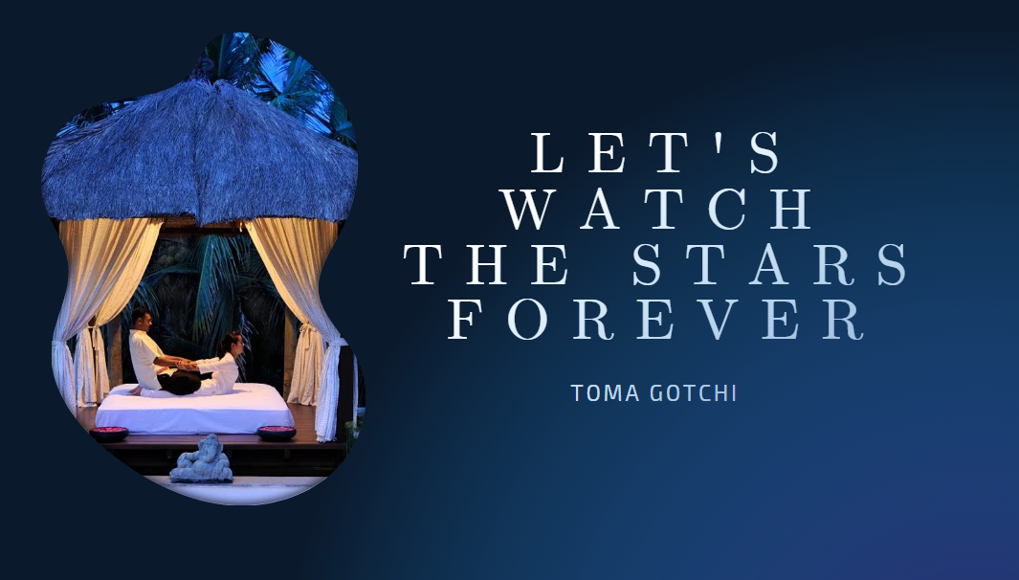

Link: <https://www.canva.com/design/DAGSUrD_L-s/L1KheyP9hHQIAsM1EUR0qQ/edit?utm_content=DAGSUrD_L-s&utm_campaign=designshare&utm_medium=link2&utm_source=sharebutton>